**Name: Sreelakshmi R**

**Roll No: 41**

**Batch: RMCA**

**Date: 25-03-2022**

**ADVANCED DBMS LAB**

**Experiment No.: 1**

**Aim**

To study various DDL commands – CREATE

**Question**

Create the following tables and insert values

#### Table 1: DEPOSIT

ACTNO VARCHAR2(5) PRIMARY KEY, FIRST LETTER MUST START WITH ‘D’ CNAME VARCHAR2(15) FOREIGN KEY REFERENCES CUSTOMER

BNAME VARCHAR2(20) FOREIGN KEY REFERENCES BRANCH AMOUNT NUMBER (8,2) NOT NULL, CANNOT BE 0 ADATE DATE

#### Table 2: BRANCH

BNAME VARCHAR2(20) PRIMARY KEY

CITY VARCHAR2(30) NOT NULL , any one of NAGPUR, DELHI, BANGALORE, BOMBAY

#### Table 3: CUSTOMER

CNAME VARCHAR2(15) PRIMARY KEY CITY VARCHAR2(20) NOT NULL ,

#### Table 4: BORROW

LOANNO VARCHAR2(8) PRIMARY KEY / FIRST LETTER MUST START WITH ‘L’ CNAME VARCHAR2(15) FOREIGN KEY REFERENCES CUSTOMER

BNAME VARCHAR2(20) FOREIGN KEY REFERENCES BRANCH AMOUNT NUMBER(8,2) NOT NULL, CANNOT BE 0

**Procedure**

**Commands:**

USE B1;

CREATE TABLE CUSTOMER(CNAME VARCHAR(15)PRIMARY KEY ,CITY VARCHAR(20)NOT NULL);

CREATE TABLE BRANCH(BNAME VARCHAR(20)PRIMARY KEY,CITY VARCHAR(30)CHECK(CITY IN('NAGPUR','DELHI','BANGALORE','BOMBAY'))NOT NULL);

CREATE TABLE BORROW(LOANNO VARCHAR(8)CHECK(LOANNO LIKE'L%')PRIMARY KEY,CNAME VARCHAR(15)REFERENCES CUSTOMER(CNAME),BNAME VARCHAR(20)REFERENCES BRANCH(BNAME),AMOUNT FLOAT(8)CHECK(AMOUNT>0)NOT NULL);

CREATE TABLE DEPOSIT(ACTNO VARCHAR(5)CHECK(ACTNO LIKE'D%')PRIMARY KEY ,CNAME VARCHAR(15)REFERENCES CUSTOMER(CNAME),BNAME VARCHAR(20) REFERENCES BRANCH(BNAME),AMOUNT FLOAT(8)CHECK(AMOUNT>0)NOT NULL, ADATE VARCHAR(30));

INSERT INTO CUSTOMER VALUES('ANIL','CALCUTTA');

INSERT INTO CUSTOMER VALUES('SUNIL','DELHI');

INSERT INTO CUSTOMER VALUES('MEHUL','BARODA');

INSERT INTO CUSTOMER VALUES('MANDAR','PATNA');

INSERT INTO CUSTOMER VALUES('MADHURI','NAGPUR');

INSERT INTO CUSTOMER VALUE('PRAMOD', 'NAGPUR');

INSERT INTO CUSTOMER VALUES('SANDIP','SURAT');

INSERT INTO CUSTOMER VALUES('SHIVANI','BOMBAY');

INSERT INTO CUSTOMER VALUES('KRANTI','BOMBAY');

INSERT INTO CUSTOMER VALUES('NAREN','BOMBAY');

INSERT INTO BRANCH VALUES('VRCE','NAGPUR');

INSERT INTO BRANCH VALUES('AJNI','NAGPUR');

INSERT INTO BRANCH VALUES('KAROLBAGH','DELHI');

INSERT INTO BRANCH VALUES('CHANDNI','DELHI');

INSERT INTO BRANCH VALUES('DHARAMPETH','NAGPUR');

INSERT INTO BRANCH VALUES('MG ROAD','BANGALORE');

INSERT INTO BRANCH VALUES('ANDHERI','BOMBAY');

INSERT INTO BRANCH VALUES('NEHRU PALACE','DELHI');

INSERT INTO BRANCH VALUES('POWAI','BOMBAY');

INSERT INTO DEPOSIT VALUES('D100','ANIL','VRCE',1000.00,'1-MAR-95');

INSERT INTO DEPOSIT VALUES('D101','SUNIL','ANJNI',500.00,'4-JAN-96');

INSERT INTO DEPOSIT VALUES('D102','MEHUL','KAROLBAGH',3500.00,'17-NOV- 95');

DROP TABLE DEPOSIT;

INSERT INTO DEPOSIT VALUES('D104','MADHURI','CHANDNI',1200.00,'17-DEC-95');

INSERT INTO DEPOSIT VALUES('D105','PRAMOD','MG ROAD',3000.00,'27-MAR-96');

INSERT INTO DEPOSIT VALUES('D106','SANDIP','ANDHERI',2000.00,'31-MAR-96');

INSERT INTO DEPOSIT VALUES('D107','SHIVANI','VIRAR',1000.00,'5-SEP-95');

INSERT INTO DEPOSIT VALUES('D108','KRANTI','NEHRU PLACE',5000.00,'2-JUL- 95');

INSERT INTO DEPOSIT VALUES('D109','MINU','POWAI',7000.00,'10-AUG-95');

INSERT INTO BORROW VALUES('L201','ANIL','VRCE',1000.00);

INSERT INTO BORROW VALUES('L206','MEHUL','AJNI',5000.00);

INSERT INTO BORROW VALUES('L311','SUNIL','DHARAMPETH',3000.00);

INSERT INTO BORROW VALUES('L321','MADHURI','ANDHERI',2000.00);

INSERT INTO BORROW VALUES('L371','PRAMOD','VIRAR',8000.00);

INSERT INTO BORROW VALUES('L481','KRANTI','NEHRU PLACE',3000.00);

SELECT * FROM b1.borrow;

SELECT * FROM b1.branch;

SELECT * FROM b1.customer;

SELECT * FROM b1.deposit;

**Output Screenshot**

Customer:

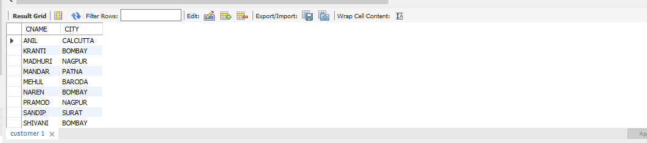

Branch:

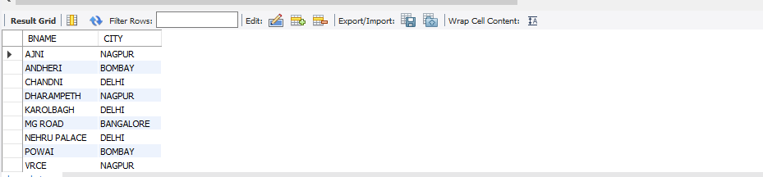

Deposit:

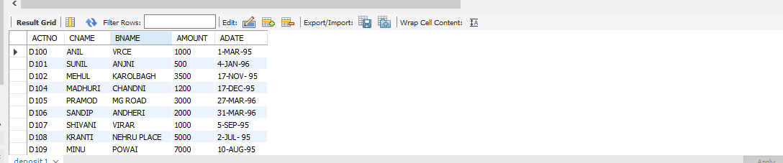

Borrow:

